# "Programming Basics" Exam

## 4. Food for Pets

Annie has two pets - a dog and a cat. Write a program that produces statistics about the **pets' food for a certain number of days**. Each day the dog and the cat eat a **different** amount of their total food. Every **third** day they receive a reward - **biscuits**. Biscuitsare 10% of the total food **eaten** for the **day**.

Your program should print **statistics** on the **biscuits eaten**, **what percent of the initial amount** of total food was **eaten** and what percent **of the food eaten** was eaten by the dog and what percent was eaten by the cat.

### Input Data

**One** line is read initially:

* Number of days – **an integer** in the range **[1…30]**
* 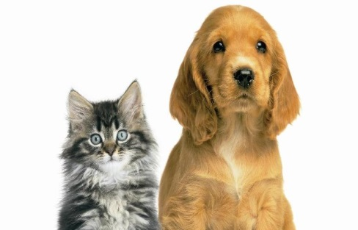Total amount of food– **a floating-point number** in the range **[0.00…10000.00]**

Then **for each day** is read**:**

* Amount of food eaten by the dog – **an integer** in the range **[10…500]**
* Amount of food eaten by the cat – **an integer** in the range **[10…500]**

### Output Data

**Four** lines are printed on the console:

* **"Total eaten biscuits: {biscuits eaten}gr."**
* **"{percentage of food eaten}% of the food has been eaten."**
* **"{percentage of food eaten by the dog}% eaten by the dog."**
* **"{percentage of food eaten by the cat}% eaten by the cat."**

**The biscuits eaten** should be rounded to **the nearest integer**, and **the percentage** of food should be formatted to **the second digit after the decimal point.**

### Sample Input and Output

|  |  |  |
| --- | --- | --- |
| **Input** | **Output** | **Comments** |
| 3  1000  300  20  100  30  110  40 | Total eaten biscuits: 15gr.  60.00% of the food has been eaten.  85.00% eaten by the dog.  15.00% eaten by the cat. | We have 3 days and a total amount of food 1000gr.  On the first day:  The dog eats 300gr, the cat eats 20gr.  On the second day:  Dog eats 100gr, cat eats 30gr.  On the third day:  Dog eats 110gr, cat eats 40gr.  On this day, they should also receive a reward - biscuits:  10% of 110 + 40 = 15gr.  Total food eaten: 600gr.  Food eaten by the dog: 510gr, by the cat: 90gr.  600gr of 1000gr = 60% of food eaten.  510gr of 600gr = 85% eaten by the dog.  90gr of 600gr = 15% eaten by the cat. |
| 3  500  100  30  110  25  120  35 | Total eaten biscuits: 16gr.  84.00% of the food has been eaten.  78.57% eaten by the dog.  21.43% eaten by the cat. |  |